LIFE SKILLS MANUAL
ADOLESCENT GIRLS INITIAVITE

Kigali, February 2013

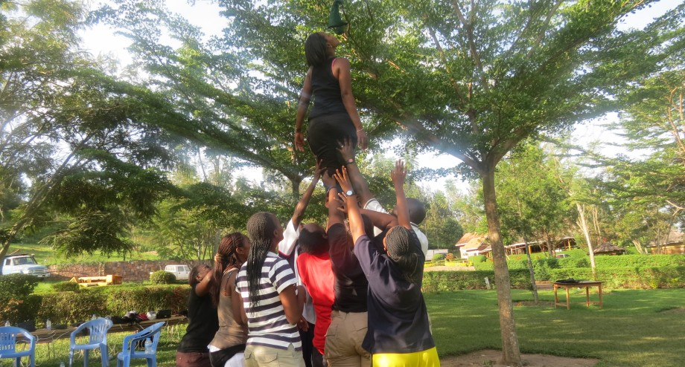

PURPOSE OF STATEMENT/ BACKGROUND INFORMATION

Adolescent Girl Initiative (AGI) is a project which is financed by World Bank, Supervised by MIGEPROF and implemented by WDA. It targets girls and young mothers who did not get the opportunity to finish their secondary education. This project aims to empower young mothers and adolescent girls with skills to help them become self-reliant. The program to be implemented focuses on both technical skills, and life skills.

Frontiers Adventures Great Lakes employed by WDA will implement life skills, and entrepreneurship. Here adolescent girls and young mothers will be empowered with skills necessary for their personal development and for creation and management of their small businesses.

This project is a tool for our Rwandan society to offer opportunity to these young mothers and adolescent girls who are agents of social transformation.

Lesson 1: INTRODUCTION OF PARTICIPANTS

Module 1: INTRODUCTION MODULE
Duration | 240min
Module description | This module provides activities to help participant get ready for the training. It offers to participants the opportunity to create bonds, become familiar with each other, and establish their expectations to perceive their own skills at the beginning of the training.
Learning objectives | In this module, participants will be able to :  - Create bonds  - Establish their expectations  - Discover they own social skills
Facilitation methods | Games, Form filling, Brainstorming, small group discussion, Peer sharing, Q&A method, short presentations
Preparations | - Take time to read different materials related to emotional intelligence  - Make sure evaluation forms are enough in the store  - Look for the translation of important terms in Kinyarwanda  - Adapt the content to the literacy level of participants, their needs and interest in this module  - Think about the venue of the training
Learning materials | Evaluation forms, Board, chalk or markers, a notebook, a pencil or pen, Talking ball or stick
Module Lessons | - Participants introduction  - Storyboarding  - Participants’ self-evaluation
Activity 1: Create bonds
Breaking the ice: Mingle mingle, RAW
- Welcome participants
- Ask them to stand on a circle
- Introduce ice breaker(mingle mingle)
- In the ice breaker ask them to form pairs, ask the participants to ask the following questions and prepare to report the answers
- What is your name?
- What are two things you expect from this training?
- Ask participants to sit in a circle. Participants should introduce their partner
- As they share write the expectations of participants, and comment on them.
- Explain the content of life skills and entrepreneurship program
- Introduce a second ice breaker: RAW
- After the ice breaker ask participants to sit on a circle and set rules for the training
- Talk about timing; assign roles, phones and, general discipline during the session.
Activity 2: Story boarding
- Ask participants to form groups of 10
- Ask them to express their expectations for this program using a picture/drawing
- After they finish the work, ask them to do a presentation of their groups
- Record different presentations
- After the presentations, make comments on their expectation and what the training will provide
Activity 3: Participant self-evaluation
- Explain the purpose of this evaluation forms and their use
- Ask 2 or three participants to share their attitudes towards this evaluation
- Distribute the forms and help participants to tick the right skill for them
- Collect the forms, and put them in the mood of working to improve their life skills
The purpose of this evaluation is to help participants to become aware of their strengths and point of improvement. This is important to you because in the goals you will set for your training you will remember to plan for a change of your behavior.

Module 2: TEAM BUILDIDNG
Duration | 480min
Module description | This module provides participants with skills to work in groups. It gives participants the awareness of their contribution in the group, the importance of thrust in the group and the kills for effective an effective communication
Learning objectives | In this module, participants will be able to :  - Perceive own trust level  - Work on values  - Practice leading team activities  - Use listening and speaking skills  - Discover barriers in communication  - Setting goals for their daily lives
Facilitation methods | Brainstorming, small group discussion, Peer sharing, case study, Q&A method, games, short presentations.
Preparations | - Take time to read different materials related to emotional intelligence  - Make sure blindfolds are enough in the store and clean  - Look for the translation of important terms in Kinyarwanda  - Adapt the content to the literacy level of participants, their needs and interest in this module  - Think about the venue of the training
Learning materials | blindfolds, Board, chalk or markers,  a notebook, a pencil or pen, talking stick or ball
Module Lessons | - Trust building  - Communication skills  - Barriers in communication

Lesson 1: TRUST BUILDING
Experiential activity: Trust walk, trio fall, trust fall
Debrief questions:
- Describe your attitude throughout the activity
- At the beginning,
- During the activity
- At the end
- List the qualities of your guide
- What helped you to go up to the end of the activity safely?
- Give your life experience related to the activity.

Activity 1: Understanding Trust
1. Building Highly Effective Relationships
Building Highly Effective Relationships Synopsis: Relationships between people can exist in many forms; however, those that are most productive, effective and rewarding operate in a state of inter-dependence. This occurs when the parties involved develop high trust in their relationships, where they:
• show respect to others
• have a strong shared purpose
• develop confidence in each other’s abilities
• communicate openly and honestly

2. Trust in Relationships
a. Spontaneous trust: This is the first and most basic level of trust that develops when we first meet someone. Spontaneous trust occurs when the people involved choose to further a relationship with each other based on their own intentions, as well as their initial perceptions of the other person’s motivations, capabilities and character.
b. Contractual trust: This is a more formalised approach to creating trust in a relationship, where the parties involved develop a purpose for the relationship, and make/keep simple agreements in the form of explicit verbal or written commitments that each rely on
c. Values-based trust: A third and more complex type of trust can be described as values-based trust (or self-disclosure trust). Here the parties make commitments to each other based on their knowledge of each other’s personal motivations, values and capabilities to fulfil expectations.
d. Safety trust: As values-based trust in a relationship matures, a fourth type of trust develops – safety trust. Here, time has allowed the parties to have their confident expectations confirmed by the actual behaviour and actions of their colleagues in a variety of testing circumstances
e. Smart trust

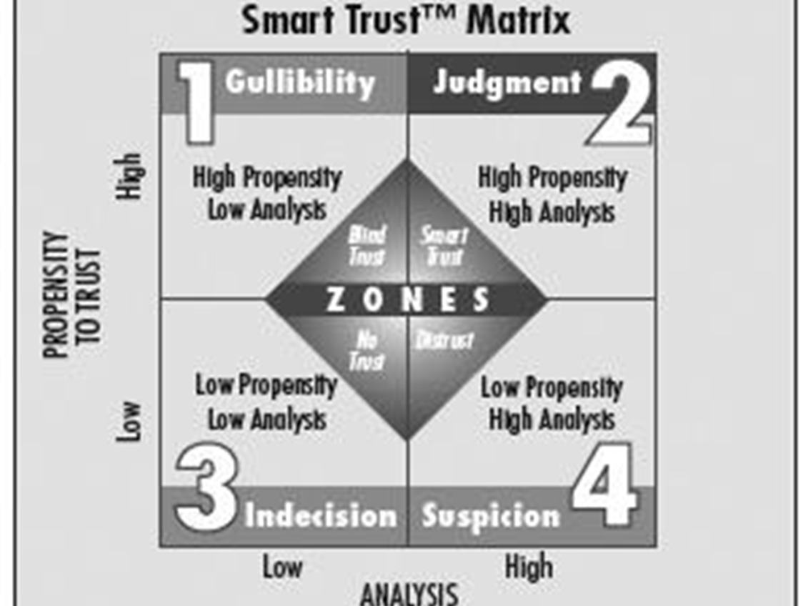
f. Elements of trust
Respect for others – appreciating diversity and valuing other people
Shared purpose – the alignment of individual and shared intentions and aspirations
Confidence in each other – the willingness to rely on the abilities/resources of others
Open and honest communication – the use of conversation and dialogue to achieve inter-dependent relationships with others

g. Trust in daily life
What are the qualities of a trusted person in our society?
Make sure that they write these qualities in their notebooks.

Lesson2: COMMUNICATION SKILLS
Experiential activity: Blind polygon, sheep and shepherd, blind shape
Debrief questions

Activity 1: Types of communication
• Verbal – Communication through language
• Nonverbal – Communication other than through spoken language. More powerful messages are usually conveyed through nonverbal cues than through words themselves. 70-90% of our communication is nonverbal. Examples of nonverbal communication include:
Body language (e.g., folded arms)
Eye contact
Muscle tension (are neck or jaw muscles taut, fists clenched?)
Posture
Mannerisms (e.g., fiddling with hair, biting nails)
Proxemics (how close we stand when talking. In the US, we stand between 18 inches to 2 ft. from each other; we get uncomfortable if that boundary is violated.
Proxemics vary from culture to culture.)
• Paraverbal – Communicating not by what you say, but how you say it. Examples of paraverbal communication include:
Voice qualities/voice tone (is voice flat or monotone?)
Rate of speech (how fast or slow one talks)
Cadence/rhythm of voice
Volume
Inflection

Activity 2: Definition of active listening
Active listening is a way of listening that focuses entirely on what the other person is saying and confirms understanding of both the content of the message and the emotions and feelings underlying the message to ensure that understanding is accurate.
Active listening is not:
• Quickly agreeing with client before they finish speaking
• Passing judgment
• Asking follow-up questions that are for your own information
• Reassuring the client that the situation is “not that bad”
• Giving advice either from your personal experience or from professionals

Lesson 3: BARRIERS TO EFFECTIVE COMMUNICATION
Experiential activity: passing pipes
Debrief questions:
Activity 1: What are the barriers of communication?
• Hearing only part of the message
• Failure to listen
• Listening with a particular mind-set/prejudice
• Reacting emotionally
• Making assumptions
• Accents
• Physical barriers
• Cultural barriers
• Religious barriers
• Time pressures
• Distractions/interruptions
• Failure to wait for feedback/response
• Lack of sensitivity to emotions
• Poor volume, tone, emphasis
• Finishing person’s sentence for him/her
• Not acknowledging person’s experience, emotions, feelings, desires
• Jumping from topic to topic
• Acting phony

Activity2: Effective communication strategies
• Making eye contact (like many nonverbal cues, this is culturally specific; in some cultures, direct eye contact is a sign of disrespect)
• Use attentive body language: sit slightly forward with a relaxed, easy posture
• Be aware of your gestures
• Stay on the topic
• Don’t be phony, be yourself
• Be cultural sensitive
• Focus on the other person
• Determine what the other person already knows, then fill in the gaps
• Smile or nod
• Don’t monopolize the conversation
• Establish rapport
• Arrange for privacy
• Create an atmosphere free of distractions and interruptions
• Be warm and enthusiastic
• Show interest
• Look bright and alert
• Ask open-ended questions
• Use active listening

Activity3: Active listening strategies
• Focus on the other person.
• Use attentive body language: sit slightly forward with a relaxed, easy posture.
• Use verbal cues such as “um-hmmm,” “sure,” “ah,” and “yes.”
• Ask open-ended questions.
• Use focused questions to get a more definitive answer than you would with an open-ended question.
Communication in daily life
1. Ask questions about how to improve communication in our team
2. Write down the outcome of the sharing for them to take notes.

Module 3: GOAL SETTING
Duration | 360nim
Module description | This module provides skills to set clear goals for their future. They also plan the use of their savings from their stipend they get to do a written plan of different activities they want to achieve during this period of training.
Learning objectives | In this module, participants will be able to :  - Understand the importance of having a goal in life  - Set clear goals  - Plan the use of their money  - Plan what they want to achieve during the period of training
Facilitation methods | Brainstorming, Peer sharing,  Q&A method, games, short presentations.
Preparations | - Take time to read different materials related to goal setting.  - Look for the translation of important terms in Kinyarwanda  - Adapt the content to the literacy level of participants, their needs and interest in this module  - Think about the venue of the training  - Think and plan the experiential activity to be used
Learning materials | Board, chalk or markers,  a notebook, a pencil or pen
Module Lessons | - Purpose of goal setting  - Smart goal  - Writing personal goal

Experiential activity: snake, ropes course
Debrief questions

Lesson1: PURPOSE OF GOAL-SETTING
Goal-setting helps you to strive to achieve. Although goal-setting may be challenging, it is generally worthwhile. Its intention is to increase efficiency and effectiveness.
The following are the most important purposes of goal-setting:
• Goals guide and direct behavior.
• Goals provide clarity.
• Goals provide challenges and standards.
• Goals reflect what the goal setters consider important.
• Goals help improve performance.
• Goals increase the motivation to achieve.
• Goals help increase you pride and satisfaction in his/her achievements.
• Goals improve your self-confidence.
• Goals help decrease negative attitude.

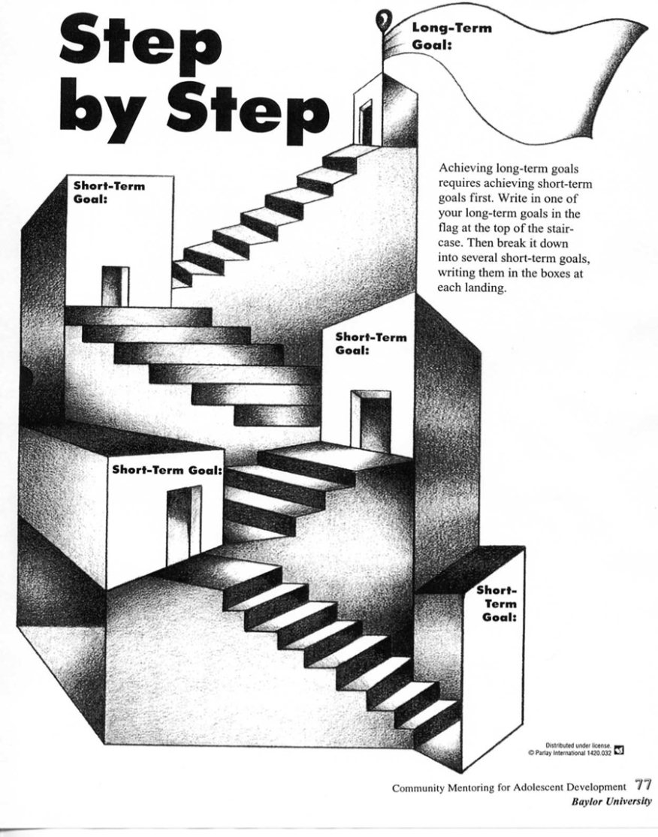
People who use goal-setting effectively suffer less from stress, are better able to concentrate, show more self-confidence, and seem to feel happier.

Activity 1: Deciding your Goal
• Attitude
Is there any aspect of your mindset holding you back?
Are any personal behaviors upsetting to you .If so, set goals to improve or cure the problem, even if the goal is only to get help.
• Education

Is there any specific knowledge that you want to acquire?
What information and skill will you need to achieve other goals?
• Social
Do you have any social ambitions?
• Career
What career are you seeking?
• Financial
What do you want to achieve in your financial life.
Goal-Setting Model

Lesson2: SMART GOAL
S-Specific
A goal of graduating from high school is too general. Specify how this will be accomplished. (Study more in order to receive better grades.)
M-Measurable
Establish criteria for how a goal is to be achieved. Measurable does not refer to a timeline; it means determining a way to measure the mentee ís success in completing the long-range goal.
A-Action-oriented
Be proactive in taking action that will result in reaching the desired goal.
R-Realistic Strive for attainable goals, considering the resources and constraints relative to the situation.
T-Timely Allow reasonable time to complete each goal, but not so much time you lose focus or motivation.
Lesson 3: GOAL SETTING IN LIFE (this is a practical lesson, participants are supposed to be guided through setting their own goals)
Ask participants to write their personal goals for six months
Help them to relate their goals to this training
Your goals | This month | Next month | In four months | In six months

Module 4: PBLEM SOLVING
Duration | 240min
Module description | This module provides skills the ability to succeed in managing and solving different problems in daily life. Participants are trained to identify their problems, go through a process of finding solutions and apply it to their daily life.
Learning objectives | In this module, participants will be able to :  - understand, and appreciate the importance of managing one own problem  - Identify their problems  - Establish a process of solving problems  - Apply problem solving to their daily life
Facilitation methods | Brainstorming, small group discussion, Peer sharing, case study, Q&A method, games, short presentations.
Preparations | - Take time to read different materials related to problem solving  - Look for the translation of important terms in Kinyarwanda  - Adapt the content to the literacy level of participants, their needs and interest in this module  - Think about the venue of the training
Learning materials | Board, chalk or markers,  a notebook, a pencil or pen
Module Lessons | - Understanding problem solving  - Problem solving model  - Problem solving in life

Experiential activity: Human knots
Debrief questions:
Lesson1: UNDERSTANDING PROBLEM SOLVING
Activity 1: Problem-Solving Model
When using this model, each step may be completed quickly, but every step must be considered. It is not necessary to document each step, but it is important to think through every step.

Step 1: Identify the problem
Step 2: Explore alternatives
Step 3: Select an alternative
Step 4: Implement the solution
Step 5: Evaluate the solution
Activity2: Problem solving in life
Ask what possible problems our team may have?
What would be the best way to solve them?

Module 5: REPRODUCTIVE HEALTH
Duration | 480min
Module description | This module provides skills to enhance the ability to decide about their sexual life. It also gives them broader knowledge about reproductive systems and family planning methods.  The module allows participants to answer certain questions in a more scientific way and identify myths and cultural impact on reproductive life.
Learning objectives | In this module, participants will be able to :  - Appreciate the importance of making decisions about their sexual life  - Understand their reproductive system  - Describe the menstrual cycle.  - Describe how conception occurs.  - Understand family planning methods
Facilitation methods | Brainstorming, small group discussion, Peer sharing, case study, Q&A method, games, short presentations.
Preparations | - Take time to read different materials related to reproductive health  - Look for the translation of important terms in Kinyarwanda  - Adapt the content to the literacy level of participants, their needs and interest in this module  - Think about the venue of the training
Learning materials | Eggs, eggplant, tomato, Avocado , Board, chalk or markers,  a notebook, a pencil or pen, poster on reproductive health
Module Lessons | - Decision making about reproductive health  - Woman reproductive system  - Family planning methods

Experiential activity: Egg drop
Debrief questions:
Lesson1: HOW TO COMMUNICATE WITH A PARTNER AND DECIDE TO HAVE SEX
Participants discuss the decision-making process for assessing whether to start or to continue a sexual relationship, the benefits of communicating with a partner. They also practice communication skills.
NOTE TO FACILITATOR:
• If participants have initiated sexual activity or already have a child, then the questions should be adapted to include both girls thinking about being sexually active and those who have already started. Remind the participants that they can still refuse sex even if they have started having sex.
• Help participants understand that going through this list of questions can be part of decision making skills: “Stop and Think,” “Consider Consequences” and “Know the Facts.”
• Remind participants of the benefits of dating someone their own age; they’ll have more in common and find it easier to communicate about mutual needs and limits.
a. Would my parents approve of me having sex now if they knew?
b. If I get pregnant, am I responsible enough to provide for the baby’s emotional and financial support?
c. Does the man I’m with make me feel good about myself?
d. Will I be glad when I am older that I lost my virginity at the age I am now?
e. If the relationship breaks up, will I be glad I had sex with this person?
f. Am I sure no one is pushing me into having sex?
g. Am I able to comfortably talk to my partner about sex, and his sexual history?
h. Am I absolutely sure my partner is not infected with an STI or HIV?
i. Do I know how to talk about using condoms or other methods to prevent pregnancy, HIV and STIs?
j. Do I feel safe with my partner?
3. Ask the participants if most girls ask themselves these questions before initiating sexual activity or continuing sexual activity? Why are they important?
4. Let participants know that if they answered no to any of these questions then they should consider not starting a sexual relationship or perhaps ending the one they are in. Decisions today affect a girl’s future, so best to be sure before starting or continuing sexual activity
Lesson 2: FEMALE REPRODUCTIVE SYSTEM
Activity 1: How Does Pregnancy Happen, Anyway?
Participants review posters on reproductive health and pregnancy.
External Organs:
• Two folds of skin are called the labia.
• The vagina is where a man puts his penis during sexual intercourse. Also, menstrual blood and babies come out of the vagina
• Near the top of the lips, inside the folds, is the clitoris. It is a very sensitive organ; its role is to help a woman have sexual pleasure.

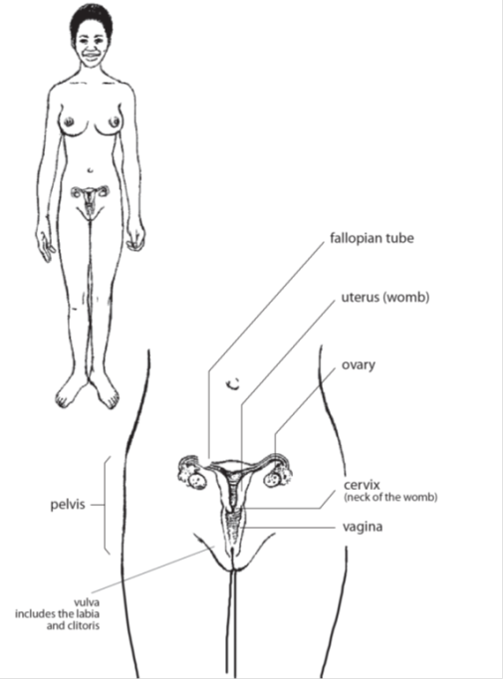
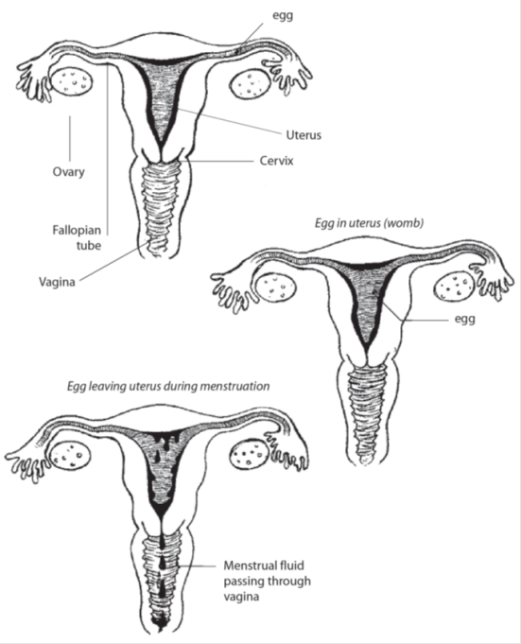

Internal Organs:
• Every female is born with thousands of eggs in her ovaries. The eggs are so small that they cannot be seen by the naked eye.
• The fallopian tubes connect the ovaries to the uterus (womb).
• The uterus is the womb where babies grow.

Menstruation
Menstruation happens for most women about once a month, and that is why it is commonly called the “monthly period.” It usually lasts between three and seven days. It is a sign that a girl or woman can become pregnant if she has sexual intercourse.
What causes menstruation? Every month the ovaries release an egg that waits in the fallopian tubes between 5-7 days to see if it will be fertilized with sperm. If the egg does not meet sperm, the lining of the womb is shed and comes out as blood through the woman’s vagina. This is the monthly period. (See “Process of Menstruation”)
Some girls may begin to menstruate at age nine or ten, others may not get their first period until a few years later. A woman knows that she has started her period when a little blood comes out of her vagina. The blood comes out slowly, like a dribble. It is important to anticipate when each month she will start bleeding, so she can wear a sanitary pad or other protection to prevent clothing stains.
While most girls menstruate monthly, some girls will be irregular. It may take the body a while to adjust to all the changes taking place. Her menstrual cycle will probably become more regular with time.
How Pregnancy Happens
Fertilization takes place when a male sperm cell meets a female egg. After the male puts his penis in the female vagina and ejaculates, ejaculated sperm swim up through the cervix into the uterus to the fallopian tubes. If a mature egg is present, fertilization can take place. Sperm can fertilize an egg up to seven days after intercourse. If an egg is fertilized, it will move into the uterus (womb) where it will grow.
Lesson3: PREVENTING UNINTENDED PREGNANCY
Participants discuss the advantages of planning their family, and learn about different types of family planning methods as well as where they can get them. This is important information for girls who are abstinent as well as for girls who are sexually active.
By the end of this session, participants will be able to:
1. Name at least two advantages of planning their family.
2. Identify where to go in the community to get family planning.
Activity 1: Family Planning
Remind participants that in the previous session the group discussed: 1) what is wanted from a relationship, 2) whether to abstain from sex or not, 3) talking with your partner about your relationship and 4) protecting sexually active couples from pregnancy and HIV.
Remind participants that every new relationship gives a girl the opportunity to assess her own needs, her relationships and her decisions. Point out that even if they have had sex in the past they don’t have to have sex in the current relationship.
2. Ask participants to share what they have heard about abstinence or family planning. The facilitator can clarify that abstinence or not having sex is the only sure way to avoid pregnancy. There are family planning methods that can be used to prevent pregnancy. These are temporary methods such as pills, condoms, injectable, IUDs and permanent methods such as laparoscopy (for women) or vasectomy (for men).

Module 6: MANAGING MONEY
Duration | 240min
Module description | This module provides skills to help participants reduce costs plan their expenses, do record keeping and budgeting. Participants get the awareness of the use of money.
Learning objectives | In this module, participants will be able to :  - Decide what and why to buy  - Decide why a and where to save  - Record their expenses  - Budget their money
facilitation methods | Brainstorming, small group discussion, Peer sharing, Q&A method, games, short presentations.
Preparations | - Take time to read different materials related to financial literacy.  - Look for the translation of important terms in Kinyarwanda  - Adapt the content to the literacy level of participants, their needs and interest in this module  - Think about the venue of the training
Learning materials | ,Board, chalk or markers,  a notebook, a pencil or pen
Module Lessons | - Reducing costs  - Saving  - Record keeping  - Budgeting

Introduction: Ask a question: What do the words manage your money mean for you?
Lesson 1: REDUCING COSTS
Work out how to get enough money for things you want
Saving
Make good financial choices
Learn about the risks associated with each type of work you are considering in order to make safe choices concerning your job and your business.
Some jobs lack legal protection and/or have employers who do not respect the rights of workers. You may find yourself seriously exploited and without security. If the work you do is illegal, you could end up in jail.
If you are a young woman, you probably will face some unique challenges in earning money sometime during your life.
Women are a critical part of the labor force throughout the world. They do both paid and unpaid work that is essential to the economy. In most countries, the majority of women participate in the labor force. However, gender stereotypes put women at a disadvantage in the workplace. Women often have access to a more narrow range of job possibilities than men. The lowest paying jobs often have a high proportion of women. Jobs and occupations dominated by women generally have lower average earnings than those dominated by men. Women who work in the same jobs as men often earn less. If you are a young woman entering the work world, this may affect your access to certain jobs or occupations and reduce your earnings.
Women often face more challenges than men in juggling work and family roles.
Women generally spend more hours working in unpaid household activities such as child care, cooking, and cleaning than men do. This increases stress and reduces the amount of time they have for rest and leisure activities.
The risks of sexual harassment and coercion are greater for women. If you are a young woman, it is important that you learn to recognize what sexual harassment and coercion are, and that you talk to other women about how to deal with these issues. It is essential that you know how to establish boundaries with work colleagues and learn how to protect yourself from unwanted comments or advances.
Activity1: How do we get money
Save until we have enough money
Borrow money to pay for it
Buy it on credit (get it now but pay for it later)
Work to earn the money
Cutting costs
RE-USE
(Reusing items that are still in good condition rather than buying new ones)
What can you use again to save money?
REPAIR
(Fixing things that are broken, but if given a little time and energy, can be made useful again)
What can you fix to save money?

RECYCLE
(Taking old, used materials and giving them new life as a different or slightly altered product)
What waste items can you make useful in order to save or make money?
REDUCE
(Decreasing the quantity of something being used)
What can you use less of to save money?

lesson2: SAVING
Savings are essential for good money management. People save by putting money aside when it comes in and spending less when it goes out. To save, you need to spend less than you earn. Savings can be kept in banks.
Developing the discipline to save is one of the most important things that can be done to manage money.
Why to save?
People save to:
Meet financial goals:
Most of us have dreams or wishes about things we want to buy. In the short term, you might want to buy a cell phone; in the longer term, you might want to own a business. You can meet financial goals like these by saving money on a regular basis. Deal with emergencies. Unexpected emergencies such as an illness, theft, burglary or fire usually mean unexpected expenses that can cause financial hardship. Savings can help to deal with these expenses. Without them, you may have to borrow money and to work extra hard to pay back the loan.
Your savings will help you respond to the emergency, allowing you to get back on your feet faster.
Take advantage of future opportunities. When an opportunity arises—such as the chance to go to school, start a business or get a good deal on a purchase you want to make you can use your savings to take advantage of it.
Meet Financial Goals with a Savings Plan
Having a financial goal will motivate you to save. Each person’s goal will be a little different. It is important to save for the things which are most important for you. A savings plan guides the way you manage your money so that you can meet your financial goals.
The following steps will guide you in developing a savings plan.
Decide on a financial goal: something that you want to save for.
Example: Imagine your goal is to attend a computer training program that will start 10 months from now. The course tuition is 20,000fr. This is your financial goal.
You can think of your personal financial goals as short-term or long-term.
Short-term goals concern things you want or need immediately or in the next few weeks or months, like a new dress or a pair of jeans. Long-term goals involve things you want or need in a year or more. Examples could be taking a trip, getting your own place, or buying a motorcycle.
Calculate your savings target: the amount you need to save over a period of time to meet your savings goal.
Example: The tuition for the training program is 20,000fr and you have 10 months to save that amount. You must save 2000fr each month. This is your savings target.
3. Make a savings plan to help you meet your savings target. Look at the amount of money you expect to get each month, including money you earn, allowance from your parents and gifts. Calculate the amount you could put aside towards saving for the course tuition.
There are four main ways to save: Reduce, Repair, Recycle, and Reuse. If you don’t have enough money coming in to save 2,000 each month, think of ways you could increase your income. Work additional hours or take on other odd jobs. Next, identify ways you might be able to cut back on expenses and put this money into your savings.
Example: Spend less on video rentals, sodas, clothes and other non-essential items.
If you realize that saving 20 a month is too ambitious, adjust your savings target.
Example: Make your savings target 1000fr a month. It will now take you 20 months to save up for the computer training program.
Ways to Save
Do you really want to be able to manage your money well? Find the discipline to save, and make it a habit.
Save regularly. Try to save something, even a small amount, every day or week. When you put money into your savings on a regular basis it will become more automatic. Even small amounts add up. Develop this habit when you are young and it will become easier as you get older.
Take stock of your savings plan. Regularly check the amount you have saved and the amount you have to fall back on in an emergency and/or how close you are to your goal. This is the best way to see how the small amounts you put aside grow into larger savings. When you have saved enough to feel more secure or meet a financial goal, you will be motivated to keep saving!

ASK THESE QUESTIONS TO HELP YOU DECIDE WHERE TO SAVE
1. How old do I have to be to open a bank account?
2. How much money do I need to open a savings account?
3. How can I avoid monthly fees on the account?
4. What are the charges for deposits and withdrawals?
5. What is the minimum amount I can deposit?
6. Can I withdraw my money at any time?
7. How do I keep track of my deposits, withdrawals and balance?
8. What rate of interest does the bank pay on this account?

Lesson3: BASIC RECORD KEEPING

Activity 1: Why should I keep records?
Everyone in business must keep records. Keeping good records is very important to your business. Good records will help you do the following:
•Monitor the progress of your business
•Prepare your financial statements
•Identify source of receipts
•Keep track of deductible expenses
•Prepare your tax returns
•Support items reported on tax returns
Basic record: (practical)
Money in, Money out, money in my pocket

Lesson 4: BUDGETING
A budget is a summary of estimated income and expenses, including savings, over a period of time (for example a week or month). It is a plan for spending and saving money. A budget helps you make decisions about how much money you can spend. A budget helps you take control of your money and serves as a guide to help you live within your income.

Creating a budget involves three basic steps:
1. Estimate your expected income over an average week or month including income you receive from work, allowances, gifts or other sources.
2. Estimate your expected expenses over the same period of time. Think about all the things that you spend money on and estimate the amount you spend on each item (on average) every week or month. You should include both necessities, such as rent, school fees, food, clothing and transportation, and non-essential items such as entertainment.
3. Estimate the amount you expect to save every week or month. Here is where your savings plan comes in—it will help you create your budget.

Budget Items
Amount (estimated average per week or month)
Income
After school job
Allowance
TOTAL INCOME
Expenses
Necessary
Food
Transportation
Health
Education
Savings
TOTAL EXPENSESS
TOTAL SURPLUS/DEFICITT

STAY WITHIN YOUR BUDGET TO MEET YOUR FINANCIAL GOALS!
Follow your budget. Don’t spend more than the amount you have allocated to each expense, especially non-essential items. This is difficult!
Review your budget regularly and adjust it as your income, spending, and savings change.

Module 7: LEADING A TEAM
Duration | 480min
Module description | This module provides skills to enhance the ability to lead team activities. It empowers participants with ability to organise team members, to manage different characters in a team and to discover their own talents to lead a team activity. The module develops skills to manage a team in order to help the team achieve intended goals.
Learning objectives | In this module, participants will be able to :  - Analyse the qualities of a leader  - Lead a team in decision making process  - Deal with different characters in team members  - Lead a team through difficult situations
Facilitation methods | Games, brainstorming, small group discussion, Peer sharing, case study, Q&A method, short presentations.
Preparations | - Take time to read different materials related to leading a team  - Make sure blindfolds are enough in the store  - Look for the translation of important terms in Kinyarwanda  - Adapt the content to the literacy level of participants, their needs and interest in this module  - Think about the venue of the  Training
Learning materials | blindfolds, Board, chalk or markers,  a notebook, a pencil or pen
Module Lessons | - Decision making as a team  - Analysing the qualities of a leader  - Developing team spirit  - Supporting effectiveness of a team

Lesson1: DECISION MAKING
EXPERIENTIAL ACTIVITY: DECISION PATH (MAIZE), TRAFFIC JUMP
Debriefing questions
What were the qualities of leaders?
What was the behavior of team members?
What difficult did leaders encounter?
How did they solve them?
To be successful, teams need:
A common purpose or goal
Clear roles and tasks
Decision making procedures
Trusting relationships among team members
These four areas are listed in order of priority. So, in order to facilitate a team, a leader needs to address the goals first, then the roles and tasks, followed by the decision making procedures and finally the personal relationships within the team.
Goals
All team members need to understand and accept the team’s objectives.
Roles
All team members should understand what is expected of them.
Procedures
All team members should know how decisions are made and in what ways problems are solved. An effective team works with defined procedures to come to a unanimous decision so that action can be taken.
Trust
All team members should feel safe and supported.
Aspects of teamwork:
A group of people does not necessarily make a team. A team can be defined as a group of individuals working together to reach a common goal. To make a team work, the supportive supervisor must look at different elements:
- Developing a team spirit
- Working as a team

As a leader you can do the following to develop a team spirit:
Work with the team to develop a common goal that is known by everyone
Nurture a sense of belonging, and focus on what the team members have in common
Make all team members feel that they have something to contribute
Help team members work together harmoniously and efficiently to solve problems
Encourage members to set aside some of their personal goals and desires for the benefit of the team
Treat team members fairly and equally
Structure the work of the team in a simple and logical fashion; make sure it is distributed fairly
Manage the team efficiently so that work proceeds in a timely manner
Create an environment that supports and rewards openness, creativity, trust, mutual respect and a commitment to provide high quality services
Working as a team means:
Team members consulting each other
Team members helping each other
Team members complementing each other
Team members encouraging and motivating each other
The following strategies can be used by the leader to support the effectiveness of the team:
Encourage discussion
Ensure that all team members understand that their ideas and opinions are equally important and relevant
Encourage everyone to participate fully
Model respect towards everyone
Encourage people with different abilities and personalities to work together
Remain calm
Use positive feedback
As a leader, what can you do to encourage team work when you are not there?
Teams can work independently if team members:
Are aware of their strengths and weaknesses
Are able to set their own goals
Are able to act according to those goals
Take responsibility for their action
As a leader this means that you need to support staff in helping them to understand their own individual strengths and find support in their colleagues.

Module 8: GOOD PARENTING
Duration | 240min
Module description | This module provides skills to enhance the appreciation of the qualities of good parents and think about the way they would raise up their children and discuss the challenges of parenting. It empowers participants with ability to change behaviors in their families and start initiatives of good parents.
Learning objectives | In this module, participants will be able to :  - Have basic knowledge about challenges of parenting  - Become familiar with qualities of good parents  - Take good resolutions about raising up their children.
Facilitation methods | Brainstorming, small group discussion, Peer sharing, case study, Q&A method, short presentations.
Preparations | - Take time to read different materials related to good parenting  - Look for the translation of important terms in Kinyarwanda  - Adapt the content to the literacy level of participants, their needs and interest in this module  - Think about the venue of the training
Learning materials | Board, chalk or markers,  a notebook, a pencil or pen
Module Lessons | - Basics of good parenting  - Challenges of parenting  - Qualities of good parents

Lesson 1: THE BASICS OF GOOD PARENTING
Good parenting is a concept which is very related to our cultural understanding of who parents are supposed to be.

Activity1: Opinions about parenting
- Raising children is the responsibility of the woman.
- There are some people who should never be allowed to be parents.
- Parenting takes up your time, energy and money.
- Every man needs a son to carry on his name.
- People who decide not to have children are selfish.
- Without children, a woman will never feel fulfilled, satisfied, or content.

Give an examples of a parenting belief or practices that are important in our culture ………………………………………………………………………………………………………………………………………………………………………………………………………………………………………………………………………………………………………………………………………………………………………………………………………………………………………………………………………………………………………………………………………

Activity2: PARENTING CHALLENGES
Tick yes or no and explain your answers

QUESTIONS | YES | NO | WHY
Do you like children?

Do you have the patience to raise a child?
Would you beat your child if he/she misbehaved?

Are you financially able to support a child?
Would having a child interfere with your plans?

Can you find happiness in teaching /guiding a child?

Could you accept and love a child who was disabled?
Would you be willing spend your life being a devoted parent?

Would you expect your child to take care of you in your old age?

Lesson3: SOME OF THE QUALITIES OF A GOOD PARENT

Fathers
- He takes responsibility for the children.
- He cares about the children and tries to provide them with a better life than he has.
- He spends time with the children and helps them to develop knowledge and skills.
- He knows the importance of showing love and affection.
- He financially supports the children.
- He tries to maintain a good relationship with the children’s mother.
- He makes decisions based on what is good for the children.
- He knows how to care for children or is willing to learn.
- He is willing to give up things to be a good father.
- He wants to keep his family healthy by not exposing himself or their mother to diseases like HIV.
He plays with his children, reads to them, and engages in youth-centered activities
Mothers
- She cares about the children and tries to provide them with a better life than she has.
- She spends time with the children and helps them to develop knowledge and skills.
- She knows the importance of showing love and affection.
- She tries to maintain a good relationship with the children’s father.
- She makes decisions based on what is good for the children.
- She knows how to care for children or is willing to learn.
- She wants to keep her family healthy by not exposing herself or their father to diseases like HIV.
- She plays with her children, reads to them and engages in youth-centered activities.

Module 9: HEALTHY LIVING
Duration | 240min
Module description | This module provides skills to enhance the hygiene of body and wearing of the participants. It gives knowledge about the germs and diseases caused by luck of hygiene. It gives ability to choose healthy life styles and to prepare balanced diet.
Learning objectives | In this module, participants will be able to :  - Describe the process of keeping your body and wearing clean  - Give examples of how to prevent diseases caused by germs  - Explain the concept of “Own your health”  - Distinguish between a healthy and unhealthy lifestyle
Facilitation methods | Brainstorming, small group discussion, Peer sharing, case study, Q&A method, games, short presentations.
Preparations | - Take time to read different materials related to health life styles  - Look for the translation of important terms in Kinyarwanda  - Adapt the content to the literacy level of participants, their needs and interest in this module  - Think about the venue of the training
Learning materials | Board, chalk or markers,  a notebook, a pencil or pen
Module Lessons | - Personal hygiene and wearing  - Nutrition  - Healthy life styles
Amagara araseseka ntayorwa (When life is scattered it can not be gathered again)
Session one 1: Personal Hygiene, nutrition and healthy lifestyle

At the end of this session, girls must be able to:

Lesson1: PERSONAL HYGIENE AND WEARING

Definition
Personal hygiene is keeping one’s body, home and surrounding area clean and free from dirt and disease. Practicing personal hygiene helps keep germs away from the body and plays an important role in healthy living.

Activity 1:Here are some examples of good personal hygiene:
- Bathing two or three times a day with soap and clean water.
- Washing hand regularly with soap and clean water, especially always after using the latrine, and before and after eating.
- Brushing or cleaning teeth after every meal, at least twice a day.
- Keeping hair clean, brushed, or braided.
- Keeping ears and nose clean.
- Trimming fingernails and toenails regularly, and keeping nails clean.
- Washing clothes regularly.
- Wearing clean clothes regularly, particularly underwear.
- Keeping the house clean by sweeping and washing floors, tables, and bedding.
- Washing the bathroom and kitchen regular with soap and water to prevent the spread of germs.
- Boiling water for drinking or cooking to clean it and make it free from germs.

Activity2: What are germs?
Germs are very small bacteria or viruses that can cause disease. These can be spread in many ways:
- Through the air by sneezing or coughing
- Direct contact with people (including hand –shaking)
- Direct contact with objects or surfaces that have germs on them
- Eating food with germs
- Touching animals

How do you help prevent germs from getting you or others sick?
One excellent way is by washing your hands very often.

When do you wash your hands?

- Before eating
- Before preparing food
- After using the bathroom
- Before and after treating wounds
- After touching a sick person
- After handling garbage
- After blowing your nose, coughing or sneezing
- Before breastfeeding

What is the proper way to wash your hands?

- Wet your hands with running water if possible.
- Apply liquid, bar or powder soap.
- Lather well.
- Rub your hands vigorously for at least 20 seconds. Remember to scrub all surfaces, including the backs of your hands, wrists, between your fingers and under your fingernails.
- Rinse well.
- Dry your hands with a clean or disposable towel or let them air dry.
- If possible, use your towel to turn off the faucet.

According to UNICEF, washing hands can save 400 children’s lives every day. So, it is important to encourage others to also wash their hands. http://www.unicef.org/media/media_51420.html

Washing and Cooking Food:
As important as it is to wash one’s hands thoroughly, you also need to wash food off before eating it so that you do not ingest germs through food. You need to use a clean water source to wash off fruit and vegetables (as well as preferably a type of sanitizer such as Sur Eau if you are going to eat the vegetables raw) before preparing to eat or serve. Also, it is important to cook the food thoroughly to get rid of germs that could be on the food. This is especially important and can get rid of a lot of unseen germs Remember that food grows in manure and you would rather have these germs removed by washing and cooking them out.

Washing Dishes and Storing Food
Germs can also be on dirty dishes and cooking pots and pans. So, before and after using the cooking supplies (including utensils) you should wash these with soap and water (preferably hot water when possible). Also, when you are storing food, try to make sure that it is sealed in a bag (to prevent rodents from getting to it). If you see rat droppings in the food, you should throw it out. Rodents carry many diseases that can make you sick. Additionally, never consume any bread or other food products with visible mold. The food has gone ‘bad’ at this point and must be thrown out as it could make you sick.

Keeping Your Work Area Clean
If you are planning to enter the workforce, especially in a restaurant, it is very important to keep your assigned workstation clean by washing it thoroughly with either a sanitizer or a soap often throughout your shift. Food is touching your workstation and can be contaminated by an unclean surface. So cleaning it often will help prevent germs getting you or customers sick.

*Note: The Ministry of Health inspects restaurants for hygiene practices, so it is important that all areas remain clean so your employer will be happy with you and your work.
In Summary,Germs, or microbes, come from many different origins (including food itself) and can be kept out of food by taking some basic, simple precautions:
Sources of Microbes | Prevention Techniques
Contaminated kitchen surfaces | Ensure surfaces are kept clean; keep refuse containers clean and away from food being prepared.
Dust | Keep surfaces clean.
Insects, rodents and pets | Keep them away from food - particularly for dry foods kept outside of refrigerators or freezers, store in tightly sealed containers.
Dirty hands and dish cloths | Wash regularly.
Raw foods | Keep foods separate to prevent cross-contamination; carefully wash preparation surfaces and utensils between uses for different foods.  Take particular care with surfaces and utensils used to prepare meat and poultry to prevent potential spread of salmonella.

Lesson2: NUTRITION AND HEALTHY LIFESTYLES

Definition
Good nutrition and good food preparation go hand in hand. A daily diet of healthy food, along with exercise and rest will help you to look and feel better and to have vitality and energy for your active life-style.
Healthy ways of living means more than just preventing illnesses such as malaria and diseases. Being healthy also includes good nutrition and regular sleep and exercise, such as walking, or playing sports. Smoking, drinking alcohol, and taking drugs harm the body and weaken its ability to fight illnesses.

Good Nutrition

Nutrition means eating the right kinds of food for a healthy body. Malnutrition, obesity, anorexia and bulimia are serious diseases linked to a poor diet and low self-esteem. Anorexia and bulimia are caused by deep and complex psychological reasons. People who suffer from anorexia think they are fat even when they are dying of starvation.
Idea about healthy eating change often, but here are some basic rules to remember when you choose food.

Here are some nutritional foods that promote growth:

- Protective foods – these are foods that help protect people from getting sick and help bodies heal quickly. Examples include vegetables (carrots, tomatoes, and okra), leaf vegetables (sweet potato leaves, spinach, other leaves used in cooking), fruits (mangos, papaya, bananas, limes), and palm oil.
- Body building foods—they are foods that help bones and muscles grow strong and stay healthy. These include meat, fish legumes (beans, peanuts), eggs, and milk.
- Energy foods—these are foods that give energy needed to walk, run, and think. These include rice, grains, corn, yams, cassava, potatoes, plantains, pasta, and bread.

Girls / young women must eat healthily by:
- Choosing food that will give lasting energy. Sugar and caffeine in coffee, tea, and certain soft drinks can give you short burst of energy, but make you feel more tired later. Food that gives you lasting energy are beans and proteins like chicken, fish and meat.
- Eat plenty of fruit and vegetable. Fresh fruit and vegetables are filled with vitamins, good types of sugar and fibre. Fill up on these when you can.
- Reduce red meat. Rather choose chicken, fish or beans.
- Try not to eat too much fried food. Fried food is not good for the body. It is healthier to bake or grill meat on fire

Lesson3: HEATHY LIFE STYLES

Choosing a healthy lifestyle includes

- Getting plenty of sleep every night, eight hours if possible.
- Exercise at least three times a week (playing sports, walking to and from training center)
- Eating a balance diet, including fruits and vegetables.
- Sleeping under an insecticide- treated mosquito net.
- Avoid risky behaviors such as smoking, taking drugs, or drinking alcohol.
- Living in a clean environment/ community.
- Always eat clean and good food to avoid malnutrition.
- Eating on time to avoid dorsal? Stomach.
- Always wash hands before eating.
- Drinking safe and clean drinking water.
- Managing your stress by asking for help and taking care of yourself
- Growing your own vegetables.
- Always go to the hospital for checkups to avoid serious illness.

Practical activities:
1. Are you taking ownership of your health? Evaluate yourself.
 | always | quite often | sometimes | never
Eat healthily
Behave responsibly on roads
Ask questions and get information about my health
Visit a clinic if I am worried about my health
Avoid drugs and alcohol
Do enough exercise

Module 10: GENDER BASED VIOLENCE
Duration | 480min
Module description | This module provides basic knowledge about gender based violence. It gives them knowledge about gender roles and gender based abuse. The module provides skills to fight gender based violence and denounce it.
Learning objectives | In this module, participants will be able to :  - Analyse, gender roles  - Recognise and respond to gender based violence.  - Discuss ways to come out of exploitive situations  - Explain ways to prevent and deal with abuse.
Facilitation methods | Brainstorming, small group discussion, Peer sharing, case study, Q&A method, short presentations.
Preparations | - Take time to read different materials related to gender based violence intelligence  - Make sure blindfolds are enough in the store and clean  - Look for the translation of important terms in Kinyarwanda  - Adapt the content to the literacy level of participants, their needs and interest in this module  - Think about the venue of the training
Learning materials | Board, chalk or markers,  a notebook, a pencil or pen
Module Lessons | - Gender roles  - Gender based violence  - Exploited situations  - Preventing and dealing with abuse

Lesson 1: WHAT ARE GENDER ROLES?
Gender roles are the kinds of activities that are considered appropriate for individuals based on their sex. A person’s gender role refers to the way a community defines what it is to be a female or a male. Each community expects women and men to think, feel and act in a certain way, simply because they are women or men.
In most communities, for example, women are expected to fetch water and fuel, prepare food and care for their children and husband. Men are often expected to work outside the home to provide for their families and parents in old age and to defend their families from harm.
Unlike the physical differences between men and women, communities create gender roles, and the ideas and expectations associated with them. These roles are different depending on a community’s traditions, laws, and religions.

How gender roles are learned
Gender roles are passed down from parents to children, as well as learned from other family members and community members. From the time we are very young, parents treat girls and boys differently – sometimes without even realizing they do so. As children grow up, they accept these roles because they want to please their parents and because parents have more authority. These roles help children know who they are and what is expected of them. So in the same way that children learn their own names, they also learn about their gender and what it means to be a woman or a man in their community.
As the world changes, gender roles also change. Many young people want to live differently from their parents. But they sometimes find it difficult to change, because the family and community expect them to continue following old rules. As women struggle to gain the freedom to redefine their gender roles, they can also gain more control over the things that determine sexual and reproductive health.
Gender
Ask each learner to write on a piece of paper one thing that women can do that men cannot do. Collect the pieces of paper and put them aside.
Ask each learner to write on a piece of paper one thing that men can do that women cannot do. Collect the pieces of paper and put them aside.
Divide the board in three parts and record the responses under the appropriate columns:

What men can do | What women can do | What both can do

Review the responses under the “men” column one at a time and ask if women are also able to do each one. Remove any that women can also do and place them in the third column.
Review the responses under the “women” column one at a time and ask if men are also able to do each one. Remove any that men can also do and place them in the third column.
What should be left under the first two columns will be the biological differences between men and women.
Explain to the learners that these biological differences are called sex roles. Emphasize that they do not change over time and apply to all women and all men.
Shift the attention to the items that were put aside. Explain to the learners that these are called gender roles. Emphasize that they are created by society and therefore they vary from society to society and change over time as society changes. For example:
Men can cut sugarcane but if women want money they can also cut cane.
Men can cook meals and clean the house.
Men can take care of babies and raise children
In some societies, women build the houses whereas in other societies it is taboo. Ask learners to list more examples of how gender roles are different in different communities.
Present the following definition of gender:
Women’s and men’s roles and responsibilities that is socially determined.
How we are expected to think as men and women because the way society is organized, not because of our biological differences.
These roles do not arise from biological differences at all.
Gender Role Awareness
Read the following sentences to the learners and ask them to write the ending to the sentences in their notebook. Discuss the responses for each sentence one at a time. For some of the responses that perpetuate negative gender stereotypes ask the others if they agree or disagree with the response. Have them explain themselves.
Being a girl (or boy) makes me feel…
If I were the opposite sex, my life would be different because…
In ten years, I will probably spend most of my time…
In Rwanda, males do…
In Rwanda, females do…
One thing I would like to change about being a male/female…
Boys are better at…
Girls are better at…
Lesson3: GENDER-BASED VIOLENCE: RECOGNIZING AND RESPONDING
Quiz on Sexual Violence
Read the following questions from and ask learners to write true or false on a piece of paper.
Being drunk and “out of control” is not an excuse for rape.
If a person gives in to sexual intercourse out of fear, it is considered consent and is not rape.
Men are not ever really raped.
Physical force is used in most rapes.
Most victims of rape are adolescents and young adult women.
Women are most likely to be raped when out alone in a dangerous place, especially at night.
Having sexual intercourse with a woman after pressuring her to get high or drunk is not rape.
Ask learners to share their answers and facilitate a discussion around each of the questions.
True - Being drunk and “out of control” makes it harder for people to communicate effectively. However, it is not an excuse to force a person to into sexual intercourse.
False - Consent is based on choice, when two people have equal power. If a powerless person gives in out of fear, that is not consent.
False- Some rapes are committed against boys and men but few ever acknowledge it.
True - There is often some form of physical force or verbal threat of force. Sometimes a victim is pressured to give in to the sexual act.
True - Young women between the ages of 16 and 24 are three times as likely to be raped as other women. However, children as young as a few months or adults as old as 98 years have been raped.
False - Rape can occur anywhere. Over half of all rapes occur inside a residence, most often the victim’s home.
False - As long as a woman has not given consent, it is rape.
Define Sexual Exploitation
Ask learners to define sexual exploitation. Their definition should be similar to the following:
Sexual Exploitation is when someone uses another person to make him/herself feel good or to get something from the other person without concern about how that person feels. Sometimes, people trick or pressure others into “bad touches”. This is another type of sexual exploitation. People also force others into sex, which they did not want to be engaged in. That is called “sexual abuse” or “rape.”
Good, Confusing, and Bad Touches
Ask learners to explain whether there are different kinds of touches.
Draw three columns on the board and have learners provide examples of good touches, confusing touches, and bad touches. Some of these types of touches could be good touches or bad touches depending on the intention of the person touching. If a kiss is started by an older man with a child, it could be a bad touch. If a back rub is intended to lead to sexual activities it could be a bad touch.
Good touches | Confusing touches | Bad touches
Hugging  Holding hands  Hair brushing  A pat of the back  A doctor’s examination | Tickling  Touching private parts  Handshake with a pinch  Back rubs  A long hug | Hitting, slapping or punching  Kicking  Biting  Pinching  Forced
Explain that exploitation:
Usually happens gradually. Starts with a good touch, then a confusing touch and into a bad touch.
Usually involves tricks, threats, or treats.
Usually involves a person known to the exploited, even though it also happens with strangers.
Often involves secrecy.Can involve boys and girls.
Lesson4: WAYS TO GET OUT OF AN EXPLOITATIVE SITUATION
Read the following scenario on prevention and reporting sexual exploitation.
Jomo and Emily were sent by their mother to get some sugar from their neighbor. They have been sent there many times before. When they arrive, the neighbor (an elderly man) invites them for some fruit in the house. While they are eating the fruit, he starts rubbing Emily’s leg.
Ask learners to describe how they think Emily and Jomo felt?
Continue with the scenario. Just before Emily and Jomo left, the neighbor offered to give them some money if Emily would remove her clothes. Ask learners what they would have done if they were Emily? Jomo? Discuss their responses.
Continue with the scenario. After Emily refused, the neighbor left them alone but then gave them the money he had offered so that they would not tell anyone about the incident. Ask learners what they would do if they were Emily and Jomo.
Make sure the group decides the incident should be reported, for two reasons:
1) to protect themselves from another incident with the neighbor, and
2) to protect other children from him.
Facilitate a discussion with the following questions:
Who would they report it to?
Where do they report it?
Why could it be difficult for them to decide who to report it to?
How can the difficulties be resolved?
Remind learners that there are other people, like teachers, religious leaders, community members, who can help them resolve the problem. Emphasize the need to seek help.
Summarize this section by emphasizing that:
Not all touches are good and it is important for adolescents to know the difference between good and bad touches.
It is important to report bad touches to a parent, guardian, teacher, or trusted relative as soon as possible because these touch normally lead to more and can develop into actions such as forced sex.
Talking with a trusted adult about confusing touches can help young people decide what to do about them.
Reporting helps to protect themselves and others.
Rape and Gender Violence
Explain that rape is sexual intercourse on an unwilling male or female by the use of force, coercion, intimidation, or any kind of threat. Rape happens to a person when they do not give consent to have sex. Facilitate a discussion with the following questions:
Can men or boys be raped?
Can a husband rape his wife?
Explain that gender violence is any act done on a woman with the aim of hurting her because she is a woman. This may be physical or psychological harm including threats and intimidation in public or private.
Emphasize that as long as one person is unwilling to have sexual intercourse, it is rape regardless if it is a husband, boy, girl, wife, acquaintance, relative, employer, neighbor or stranger committing the act.
Ask the learners to identify the crime that occurs when a romantic partner forces another to have sex. If no one answers correctly, write “date rape” on the board. Make the following clear:
Acquaintance rape, also known as date rape, is forced oral, anal or vaginal sexual intercourse by someone the person knows and may even have a romantic relationship with.
Emphasize the following:
Rape is an act of aggression that uses sex to show the victim that the rapist has power.
Rape is a crime punishable by law.
Many girls in Haiti are forced or tricked into their first sexual experience.
Nothing a woman does, including using drugs or alcohol, going to “risky” places, wearing certain clothes, kissing and sexually touching or even having previously had sex with a man, gives a man the right to force her to have intercourse against her will.
Alcohol and drugs are often involved when date rape occurs. Being drunk or high makes women less able to set clear boundaries and men less inclined to listen to those boundaries.
Books and movies often suggest that women are excited by the power and force of rape and may even fall in love with the rapist, but a victim of rape never experiences the act in a positive way, even in a date situation in which the beginning of the sexual encounter was pleasant.
Lesson4: WAYS TO PREVENT AND DEAL WITH ABUSE
Ask participants to discuss why they think most rape cases are not reported:
Fear of being blamed
Fear of consequences
A false sense of obligation to protect a relative or acquaintance
Fear that no one will believe them
Fear that everyone will know about it
Fear that no one will care or listen
Divide the group into small groups and assign one “Sexual Abuse and Family Violence” case to each group. Ask each group to discuss the options and decide what they would do, considering the positive and negative consequences. Ask each group to present their case and their decision.
Facilitate a discussion with the following questions:
What if you do all the right things and are unable to stop your date from raping or assaulting you?
Does that mean you did not try hard enough? What should you do? (Answer: Whenever rape occurs, regardless of what was or was not said or done to prevent it, it is never the victim’s fault. If you are raped, get help immediately and do not feel guilty.)
What are some of the things that we have discussed that have changed the way you think about rapists? How has your opinion of rape victims changed?
What are some of the things you have heard people say about girls or women who have been raped and how do you feel about the things these people say?
What precautions can girls and women take against stranger rape? (Answer: Be alert to the surroundings; avoid dark, lonely places at night; keep doors and windows locked; walk in groups; scream for help if cornered; take a self defense class; or keep a loud whistle on a key ring.)
What are some things that girls and women can do to help prevent date rape? (Answers may include: communicate with your date, state expectations clearly, listen carefully, ask questions if things get confusing, avoid using alcohol and other drugs that cloud your judgment, and let the man know your intentions – “I like dancing with you, but I don’t want to have sex with you.”)
Remind learners that:
No matter what the circumstances, they have the right to choose when, with whom, and how they want to be sexual.
When first getting to know someone, go out with other people or groups rather than alone.
Trust your feelings – if you begin to feel nervous or uncomfortable about the way things are going, do something about it right away. Let your date know how you feel and get away from the situation to a place where you feel more comfortable.

Ask learners to list what they think someone should do if he or she is assaulted or harmed. Allow several volunteers to share the steps that they should follow. Then review the following information with the learners.
What to Do if Assaulted or Harmed
Talk to a parent or trusted adult and go to the nearest hospital or health facility for a medical exam and treatment. A doctor should confirm the assault.
Take the medical report to the police station and collect a P3 form. If severely hurt, the police should be asked to visit the health facility with a P3 form to record the crime.
Have a P3 form filled and take it to the police doctor to record the assault. (If up country, go to the District Government Hospital.)
Take back the P3 form to the police station for the arrest of the perpetrator (and keep a copy of the form for yourself if possible).
Identify the accused for arrest.
Attend court when the accused is charged.

Ask learners to list what they think someone should do if he or she has been raped. Allow several volunteers to share the steps that they should follow. Then review the following information:
What to Do if Raped
Do not shower. Do not wash any clothes, including underwear.
Talk to a parent or trusted adult.
Go to the nearest hospital or health facility for a medical exam and treatment. A doctor should provide treatment, confirm the rape, and obtain evidence. A PRC1 (Post Rape Care) form should be completed in duplicate at this time. A PRC1 form allows the P3 form to be completed effectively because it contains all clinical notes. You should be given the original PRC1.
Go to the police station where a report is entered into the Occurrence .The police should record your statement and that of any witnesses. Only sign it when you are satisfied with what is written.
.Follow your case till the accused are identified
Remind students that rape crimes need to be reported early so that treatment can begin, investigations can start, and culprits can be arrested if known.
Taking Action Against GBV
Divide the learners into groups of four or five. Explain that half of the groups will prepare a TV or radio newscast and the other half will prepare a presentation to the government.
Ask the groups to think about who is responsible for ending violence against women and girls? Have the groups prepare a 5 to 10 minute presentation (a newscast or a presentation to the government) suggesting some strategies or programs to reduce violence against women and girls. The presentation should assume that the audience already knows about the problem. Your job is to show what positive actions can be taken to respond to the problem. Try to include what has been done (or can be done) by young people as well as adults in everyday life; by local organizations and communities; by the government or UN agencies. You should also consider how to involve men and boys in this effort.
For presentations to the local/national government, explain: You will inform government officials of actions that have been taken by groups and individuals. Clarify how the government should respond. Sme students may play the role of government officials and other students may act as experts or citizens.
For the newscast presentations, explain: Remember that you need to focus people’s attention and be as clear and brief as possible. Use human-interest stories to show the work being done to address the problem of violence in personal relationships. Keep your presentation personal and engaging.
When groups have finished preparing and practicing their presentations, ask them to present to the class.
After all of the presentations have been heard, facilitate a discussion on the following questions:
How difficult was it to think of ways to reduce violence against women and girls?
What are some of the common themes or ideas that different groups had? What are the ideas for working with men and boys?
Which ideas do you think are best and why?
What, if anything, can you do know as a young woman to end gender-based violence in relationships, in families, in school and work places, and in the community?

Make sure learners understand that violence against women and girls is a worldwide problem. More and more people (males and females), organizations, communities, and governments are working to reduce violence. They do this by:

Teaching people ways to resolve conflicts without violence, including ways of expressing their feelings respectfully and effectively;
Supporting survivors of gender-based violence, including providing a safe haven where they can seek help and safety;
Working to change attitudes that tolerate or excuse violence or blame it on the victim;
Promoting norms that honor diversity and difference and that support boys and young men who choose not to adopt aggressive male roles;
Educating people about violence, including the gender norms that foster violence, the wide range of contexts in which violence takes place, the rights of all people to live free of violence, and the importance of shared responsibility for reducing violence; Advocating for the passage and enforcement of effective laws against violence.

Module 10: ANGER, STRESS AND CONFLICT MANAGEMENT
Duration | 240min
Module description | This module provides skills to enhance the ability to succeed in coping with anger and tress and conflict situations. It empowers participants with ability to perceive their own anger, stress and those of others, and so, deal with conflict situations.
Learning objectives | In this module, participants will be able to :
Facilitation methods | Brainstorming, small group discussion, Peer sharing, case study, Q&A method, games, short presentations.
Preparations | - Take time to read different materials related to anger stress and conflict management  - Make sure blindfolds are enough in the store and clean  - Look for the translation of important terms in Kinyarwanda  - Adapt the content to the literacy level of participants, their needs and interest in this module  - Think about the venue of the training
Learning materials | blindfolds, Board, chalk or markers,  a notebook, a pencil or pen
Module Lessons | - Understanding anger  - Managing anger  - Managing stress and conflicts

Lesson5: ANGER, STRESS AND CONFLICT MANAGEMENT
EXPERIENTIAL ACTIVITY: secret spots, caterpillar walk
Activity1: What is Anger?
Anger is a universal experience. We all get angry from time to time and this session is not about teaching you to never become angry, or to hide your anger. It really is about managing your anger.
You don’t have to be a psychologist to know that managing our anger is something we need to do well. Research tells us that those who do manage their anger at work are much more successful than those who don’t.

“Out of control, you are at the mercy of your anger…you need a new kind of relationship with your emotions, one where you run them instead of them running you.”
Maria Arapakis
This is really what we want to do: have a new type of relationship with our emotions, a relationship where we manage them rather than letting them manage us.
Many of us are alarmed at how anger is controlling our lives. However, anger is a learned response, and the anger response can be unlearned, with commitment and effort.
Self-awareness is a key element for managing your own anger, because the use of anger management skills presupposes that you know when you are angry and recognize that anger as a cue that something is wrong.
To understand and develop the skills associated with anger management, think of anger as five interrelated dimensions, all operating simultaneously. These dimensions are:
Our thoughts when we are angry
The emotions that our anger arouses
The ways we let others know that we are angry
How we experience the world when we are angry
How we act when we are angry
For example, what you think when you are angry influences how you feel; how you feel when you are angry influences how you communicate; how you communicate affects how you think; how you think affects how you behave.
Think of your own anger. Can you identify those things you normally think, feel, say, and do when you are angry? How does the world look to you when you are angry?
Tell the group you have a story to tell them. They may see a cost of anger they’d not thought about after they hear this story.
There once was a little girl who had a very bad temper. Her mother was a wise woman. One day she gave her daughter a bag of nails and told her that every time she lost her temper, she must hammer a nail into the back of the fence.
The first day the girl drove 37 nails into that fence. It was hard work and over the next few weeks, as she learned to control her anger, the number of nails hammered daily gradually dwindled down. She discovered it was easier to hold her temper than to drive those nails into the fence.
Finally the day came when the girl didn't lose her temper at all. She told her mother about it and the mother suggested that the girl now pull out one nail for each day that she was able to hold her temper.
The days passed and the young girl was finally able to tell her mother that all the nails were gone. The mother took her daughter by the hand and led her to the fence.
She said, "You have done well, my daughter, but look at the holes in the fence. The fence will never be the same. When you say things in anger, they leave a scar just like this one. You can put a knife in a person and draw it out. It won't matter how many times you say I'm sorry, the wound is still there. A verbal wound is as bad as a physical one.”
Family and friends are very rare jewels, indeed. They make you smile and encourage you to succeed. They lend an ear, they share words of praise, and they always want to open their hearts to us. At the end of today, ask your friends and family to forgive you if you ever left a hole in their fence.
Discussion
In the spaces provided, I asked you to write a brief description of how anger has affected you in each area. You were to put an asterisk beside any numbered item that makes you think you would like to learn more about anger management. Did any of you have costs you could identify? Any you are willing to share? I want you to think about each of these as I read them through.
How has anger affected my work relationships?
How has my anger, or someone else’s anger, affected the relationships in my family of origin?
How has anger affected your marriage or your intimate/romantic relationships?
How has anger affected my children?
How has anger affected my friendships?
How has my anger harmed people who aren’t family or friends?
How has my anger affected my health and physical well-being?
How has anger damaged me?
How has anger affected me financially?
How has anger affected me spiritually?
If any of the participants are willing to discuss their costs, this sharing can be very therapeutic. Otherwise, share some experiences you have had, if possible.
Lesson2: MANAGING YOUR ANGER
Costs and Pay-Offs
It isn’t the anger that is the problem; it’s how we express our anger. If we let it out and explode in anger, we run the risk of high blood pressure and a heart attack. If we hold our anger in, on the other hand, and don’t learn how to tell others what we are feeling, we are at risk for a stroke. Either way, we lose.
So we want to find other ways to deal with this emotion. At least in part, our anger is learned. We’ve learned how to cope with our frustrations and our hurts this way. And it has worked, at some level. There is usually some sort of pay-off for us: people do what we ask them to do, our tension is released, and for a brief moment we feel better, we feel we’ve gotten revenge. One thing you should try to do is figure out what your pay-off is.
What Are your Anger Pay-Offs?
In this exercise you will identify which of the five anger pay-offs are influencing you. Don’t be surprised if all five of them play a part in your anger.
For each anger pay-off below, do a mental inventory of relationships and situations in your life, such as anger with your family, friends, or co-workers; anger when driving; or anger at inanimate objects. See if that pay-off is in any way influencing or reinforcing your anger. If it is, write an example in the space provided.
Pay-off List:
Lesson3: MANAGING STRESS
Reduce stress
Hide emotional pain
Get attention
Punish and get revenge
Change the behavior of others/get people to do what you want
Reduce stress
Anger does reduce stress. However, there is a link between stress and anger. Stress creates physiological arousal or tension. Anger discharges that arousal—just for a minute. Right after a blow-up, people often feel like a weight has been lifted off their shoulders. They can breathe again. And even though that tension soon returns, that little sense of relief can be very reinforcing, because for just that brief period of time you get a break from all that frustrates and overwhelms you.
However, there is a downside to using anger to reduce your stress. The stress comes back with a vengeance! Studies show that anger creates more anger; blowing up makes it more likely that you will blow up again soon. And the next outburst will be that much easier and that much stronger…and harder to control.
Not only does your anger get worse, so does the anger of those around you. They get hurt and defensive. They counterattack. And they become less and less concerned with your needs and your feelings. You pay dearly for your anger in broken relationships.
Hide emotional pain
Anger does hide emotional pain. Anger is a good defense against fear, loss, guilt, shame, and feelings of rejection or failure. It puts a tight lid on painful emotions. We learn that we can cope with just about any pain if we get mad enough. (Dad is ashamed so he yells at the kids. Mom is depressed so she yells at the kids.)
But once again, short-term gain is long-term pain. First of all, when we get angry, we may not let ourselves experience emotions that may be important signals for us, telling us what we need to do or to stop doing in our lives. Maybe there is a good reason for you to feel guilty and you should face it and do something about it. Maybe you need to deal with your depression, take some responsibility and make some changes in your life.
Using anger as a way of dealing with our feelings don’t make the feelings go away either. They come back stronger than ever. You have to crank up your anger to cope.
Finally, using anger to deal with your pain becomes a habit, and you “go off” about everything. After all, it is a lot easier to blow up at your wife/husband for spending money on something the family doesn’t need than it is to sit down and have a serious talk about your finances, for example.
Getting attention
Anger does get people’s attention. Sometimes it seems like nobody listens to you unless you yell. People may get alarmed and they may try to please you. But once again, the immediate pay-off may have long-term outcomes you don’t want, and that can hurt you. Some may indeed sit up and take notice when you yell. But eventually they will begin to tune you out. Others will run. They may start to avoid you or become very resentful.
Punish
You can punish and get revenge by becoming angry too. Someone lets you down or seems careless, and this great wall of rage may rise up inside you. You want to punish them and teach them a lesson. You want them to feel as much pain as you do. This will to harm is so powerful that it’s all you care about. The trouble is, when you punish other people, they become your enemies, and your enemies then want to punish you. Sometimes these are the people you love and need the most.
Change the Behavior of Others
Anger can help you change the behavior of others and get people to do what you want. We coerce people into doing what we want by threatening to blow up at them if they don’t. It is tempting to use anger as a club because it often will force people into giving you what you want short term. However, in the long term they turn off and turn away from you. They resent being controlled by fear. But worst of all is what it does to you. Using your anger to change others leaves you feeling hopeless. The only way you know of to get others to do your bidding is to make them afraid of you.
Destructive Labeling
This is an extreme form of overgeneralization. When you use destructive labeling, you broaden one or two qualities into a negative global judgment. Examples may include calling your boss a jerk, your girlfriend a bitch, or your colleague a loser.
Destructive labeling creates and perpetuates anger because it forces you to focus on only the negative characteristics you find irritating in another person. Sometimes we label others in an effort to protect our own self-esteem. However, when you hear yourself labeling someone, step back and describe the annoying behavior with precision.
Coping thoughts:
Why am I swearing?
I feel frustrated and things aren’t going the way I’d like them to, but I can cope.
Imperative Thinking
This is when you have a list of inflexible rules about how you and others should act. For example, “You should have called me back right away if you weren’t interested.”
Imperative thinking creates anger because it implies that we are entitled to get what we want in a specific situation, or that people should be the way we want them to be. Then, when our imperatives are violated we think an injustice has taken place. Violating our own self-requirements (thinking, “I should have done a better job”) also creates anger because we perceive the violation as failure. Usually what this means is that we have unrealistically high expectations. This is a trait we often see in a chronically angry person.
Mind Reading
Rarely do you bother to check out your presumptions, acting instead as if they were ultimately true. (For example, you may think, “If my co-worker respected me, he would have asked for my opinion. Since he doesn’t, I will ignore his input too.”)
Unfortunately, we don’t have the power to read someone else’s mind. Instead we go by our assumptions, which we rarely bother to check out. Then our presumptions become self-fulfilling prophecies.
Most of what we’ve been doing is looking at your behavior over the long term, and making you aware of what has been going on in your own mind—the thoughts that trigger your anger, the distorted thoughts that can fuel your anger, and the thoughts we can use in place of these.
If you can get a handle on the type of self-talk or inner dialogue that goes on in your head all day, and have some different coping strategies, you will have made a big start toward getting your anger under control.

Module 11: EMOTIONAL INTELLIGENCE
Duration | 1200min
Module description | This module provides skills to enhance the ability to succeed in coping with life situations. It empowers participants with ability to perceive their own emotions and the emotions of others, and so, use them to develop their thinking and problem solving capacity. This module also provides competencies to comprehend emotion language and to appreciate complicated relationships among emotions.  Then the module develops skills to manage ones emotions and those of others in order to achieve intended goals
Learning objectives | In this module, participants will be able to :  - understand, use, and appreciate the emotional intelligence in life situations  - Understand different emotions and how to manage them  - Create a personal vision statement  - Understand the difference between optimism and pessimism  - Validate emotions in others
Facilitation methods | Brainstorming, small group discussion, Peer sharing, case study, Q&A method, games, short presentations.
Preparations | - Take time to read different materials related to emotional intelligence  - Make sure blindfolds are enough in the store and clean  - Look for the translation of important terms in Kinyarwanda  - Adapt the content to the literacy level of participants, their needs and interest in this module  - Think about the venue of the training
Learning materials | blindfolds, Board, chalk or markers,  a notebook, a pencil or pen
Module Lessons | - Understanding emotional intelligence  - Optimism versus pessimism  - Validating emotions in others  - Personal vision statement  - Using emotional map

UNDERSTANDING EMOTIONAL INTELLIGENCE 60MIN

INTRODUCTION -5MINS
In one of the villages here in Rwanda, two brothers were playing throwing stones to birds. The elder brother collected many good stones, the younger did not manage to collect stones since the other one has taken all those that were around. The younger brother asked the alder to give him some of his stones, the elder refused. The younger saw a bird on his way rushed to the stones of the elder, took three of them and threw them to the bird. The elder was very angry he took one stone threw it into the eye of his younger brother the eye was badly injured and was removed. Now the younger brother has only one eye.
- Who are involved in this story?
- What are they doing?
- Describe their relationship at the beginning of the game?
- Describe the behavior of the younger brother during the game?
- Describe the behavior of the elder brother as the game goes on?
- How does the game end?

In this lesson you are going to apprehend what emotions are and identify your own emotions to help you be aware of your reactions when interacting with other people at home, in your business, in cooperatives and with your neighbors.

What is emotional intelligence? 20 mins

We can’t control what happens to us but we can control how we think and feel and ultimately that affects the direction and course of our life. In our daily life we are confronted to different situations. Most of the time we find ourselves reacting immediately and this becomes our natural way of dealing with our emotions. Each one of us has this capacity to respond to what happens to us. Let us listen to different experiences.

Recall a past experience when:
- You met a feared animal
- A close friend betrayed you
- You got an unexpected gift

- What were their emotions in these stories?
- How did they respond to the emotions in these situations?
- What emotions did these stories raise in you?
- How do you use emotions in your daily life?
- Which impact do our use of emotions have to people we live with?
- How can we use better our emotions?
- What emotions are common in our life?
- When do we experience those emotions?

Emotional intelligence is the ability to identify our own emotions and the emotions of others, the ability to perceive, appraise, and express emotion accurately and adaptively.
Emotional intelligence is the ability to perceive, appraise, and express emotion accurately and adaptively; the ability to understand emotion and emotional knowledge; the ability to access and/or generate feelings when they facilitate thought (use); and the ability to regulate emotions in ways that assist thought (manage).”
PUUM model from the above definition
P: Perceive
U: Understand
U: Use
M: Manage

Emotions

The Seven Human Emotions
Most social scientists agree that there are seven emotional expressions that are basic to every culture.
According to Dr. Paul Ekman, a renowned psychologist, the seven emotions are:
- Sadness
- Anger
- Fear
- Happiness
- Surprise
- Contempt
- Disgust

What Do Emotions Tell Us?

Emotion | What it tells us
Sadness | Lost something of value
Anger | Way is blocked or get out of my way
Fear | Possible threat – be prepared
Happiness | Gained something of value, the way is safe
Surprise | Something unexpected happened
Contempt | Not worthy of care, hardening of feelings
Disgust | Rules are violated

Fill the following table
Action | Emotions | Reaction
My mother reprimands me
My colleague insults me
I meet a snake
My best friend visits me
My Father/mother is very sick
There is a wedding of my sister/brother

Write a paragraph of at least five lines about how you are going to use emotional intelligence in your life from now.

Identifying your emotions and the emotions of others

Caterpillar walk-10min
- Draw boxes equal to the number of participants
- Call participants to stand on a circle
- Give each participant a blindfold
- Ask participants to tie smoothly their right leg to the left leg of the participant next to them
- Instruct participants to cross the boxes without untying their legs
- Not more than two legs are allowed in the same box.
- Observe and listen to participants as they do this exercise
- Take your notebook and write different reactions of participants
- After the activity call them to seat on a circle

Debrief questions-5mins

- What were your feelings at the beginning of this activity?
- What reactions did you observe from your colleagues during the activity?
- What was the response of the team to those reactions?
- Which emotions did you observe from those reactions?
- How can we handle our emotions wisely?
- Share your life experiences where you used your emotions wisely.

Think more about your emotions -10mins
- How do our emotions affect others?
- How do you recognise your emotions?
- What emotions are frequent in your life?
- What lessons did you learn from the game?
- What steps can we use to manage our emotions?
- How can we identify the emotions of others?
- What factors influence our use of emotions?

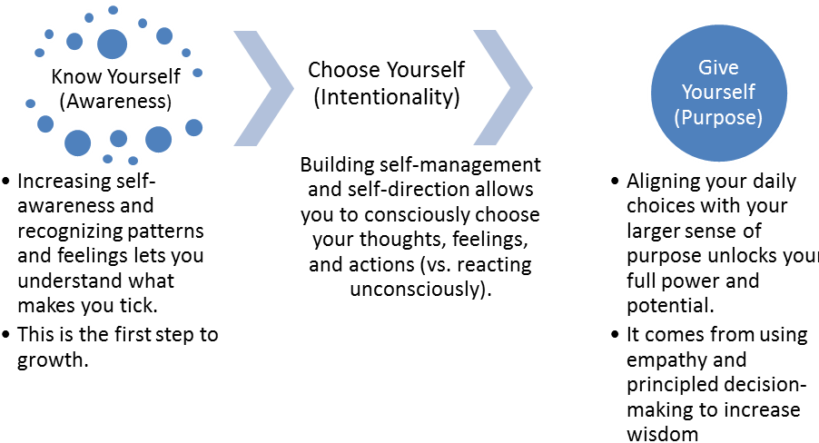

Validating Emotions in Others
Use the VALUE technique when someone is talking:
V | Validate
A | Ask questions
L | Listen, especially listen to the vocal (the tone) as well as the verbal (the words)
U | Understand the meaning that can be behind the words
E | Empathize

Validation does not mean solving a problem or offering a solution. When we validate we acknowledge that we heard what the other person was saying. When someone is talking, listen without interrupting. Paraphrase, nod your head, or make appropriate listening responses to what they have said to show you are listening. Allow for pauses and silence.
Use the SOLER technique while you are listening:
S | Sit quietly with your arms and legs uncrossed. Crossed limbs can be interpreted as unwilling to listen, closed-minded.
O | Maintain an open posture.
L | Lean slightly forward in the direction of the speaker.
E | Maintain eye contact. Be sensitive though – some people are uncomfortable with extended eye contact.
R | Stay relaxed. Pay particular attention to your shoulders and neck.

Ask open-ended questions that require more than a yes or no response. Ask the person for their perception of the problem.
Listen to what the person has to say. Defer judgment on what someone is saying and focus on finding out more. Don’t jump in with a solution when someone is starting to express their concerns. Continue to listen until the speaker has finished.

Be aware of yourself  Remember five of your usual emotions | choose yourself  Think about how you can react | Have purpose  What is important in your life?

- Ask participants to form groups
- Instruct them to prepare a short drama
- The drama should show the understanding of emotional intelligence.

PERSONAL VISION STATEMENT -2hours
- Ask participants to go in groups
- Ask each group to choose a secretary
- Tell them to list all the values
- Give them 15mins for this group work
- Tell them to prepare a written presentation
- Write common values
- Ask each participant to choose among those values four that are very relevant to them
- Ask participants to write four of their talents
- Ask participants to imagine when they will be very old, what do they want people to say about them
- Make them write their statement:
I …………………………….wish to…………………………………., I will achieve that by………….

Optimism v/s pessimism
- Ask participants to think of a project that they once thought of doing but never did it
- Ask them about something they once thought of doing and realised it
- Ask them to think about why

Adapted from Advocates for Youth.
Adapted from: The International Sexuality and HIV Curriculum Working Group. 2009. It’s All One Curriculum: Guidelines and Activities for a Unified Approach to Sexuality, Gender, HIV, and Human Rights Education. New York: The Population Council, Inc.

